APWH RHS
S.P.I.C.E.
5 Themes of
AP World History

S.P.I.C.E. Themes
- The Five themes of AP World History serve as unifying threads through which you can examine broader themes throughout each period. We use the acronym S.P.I.C.E. [Social; Political; Interactions between humans and the environment; Cultural; Economic] to help you categorize and remember the 5 areas of analysis.
- Civilizations rarely exist in a vacuum. Think of the ‘Big Picture.’
- It is highly recommended that you have this handout with you during lectures & while reading the textbook. You can word process charts or hand-draw them.
Theme 1: Development and

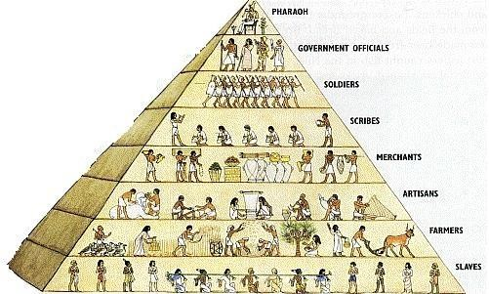
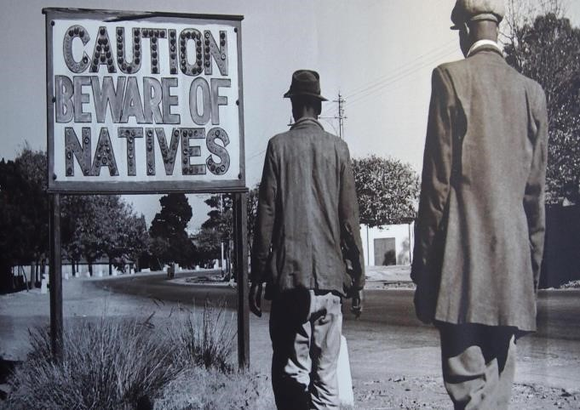
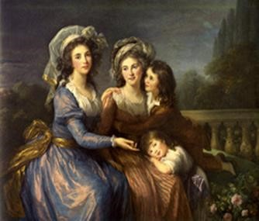
Transformation of SOCIAL Structures
- Gender Roles and Relations – Family and Kinship – Racial and Ethnic Constructions
- Social and Economic Classes –
- World History requires analysis of the processes through which social categories, roles and practices were created, maintained and transformed.
- Relationships among human beings. All human societies develop ways of grouping their members, as well as norms that govern interactions between individuals and social groups.
- Social stratification based on kinship systems, ethnic associations, and hierarchies of gender, race, wealth, and class.
- Social System
- How does the group relate to one another?
- How do people communicate?
- What do people do together?
- How is the group organized (hierarchies)?
- What are the family and gender relations (patriarchal/matrilineal)?
- Are there ethnic and/or racial divisions?
- Are there social & economic classes, inequalities?
Theme 2: POLITICAL - State-Building,
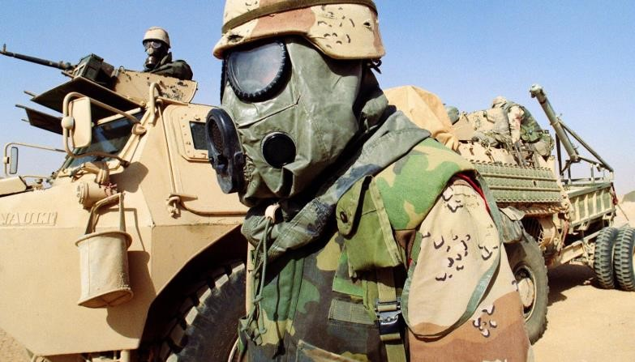
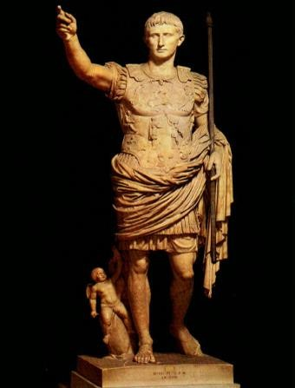
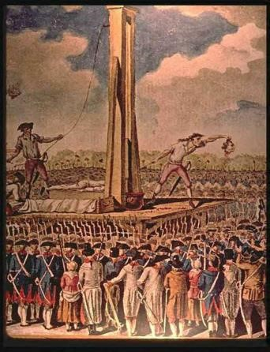
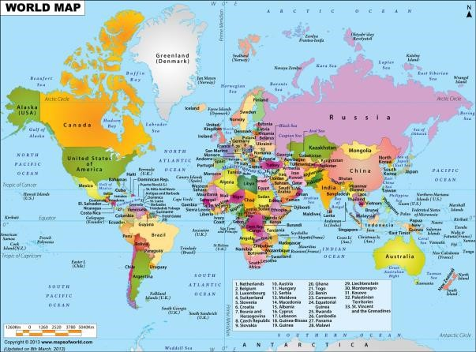
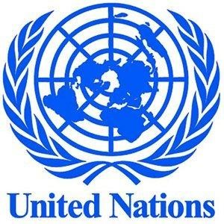
Expansion, and Conflict
– Political Structures and Forms of Governance – Empires – Nations and Nationalism – Revolts and Revolutions – Regional, Transregional, Global Structures and Organizations –
- Refers to the processes by which hierarchical systems of rule have been constructed and maintained and to the conflicts generated through those processes.
- Comparative study of different state forms (kingdoms, empires, nation-states) across time and space, and the interaction among them.
- Continuity and change are also embedded in this theme through attention to the organizational and cultural foundations of long-term stability vs. internal and external causes of conflict.
- Examine and compare various forms of state development and expansion in various productive strategies (agrarian, pastoral, mercantile), various cultural and ideological foundations (religion, philosophies, ideas of nationalism, various social and gender structures, and in different environmental contexts.
- Discusses different types of states, such as autocracies and constitutional democracies
- Explore interstate relations, including warfare, diplomacy, commercial and cultural exchange, and the formation of international organizations
- Political Systems  Who is in charge?
- How much power do they have?
- How is power transferred?
- Is there a bureaucracy?
- Who chooses the leader/s?
- What is the structure (e.g. theocracy, absolutism, democracy, communism)?
- Are there revolts and revolutions? If so, what was the cause and the effect?
- Are there significant wars, treaties, courts or laws?
- Did the political boundaries change over time?
- Did political power shift over time?

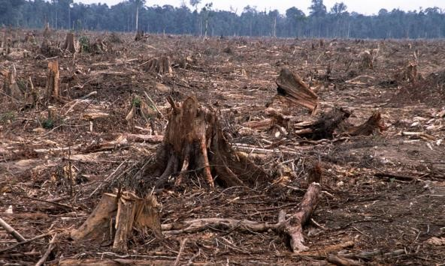
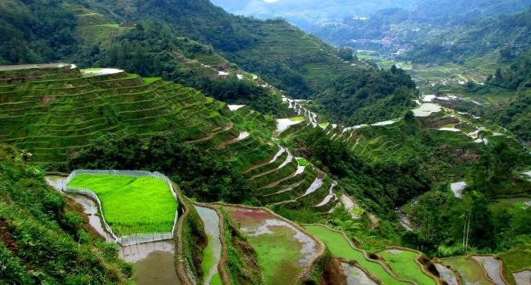
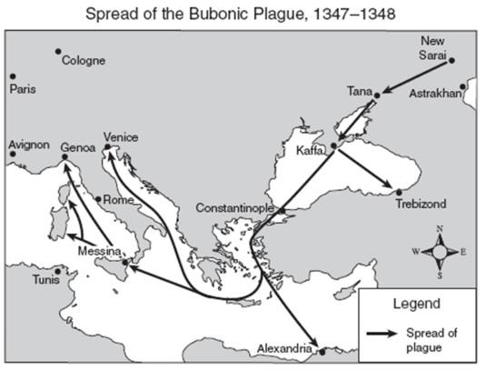
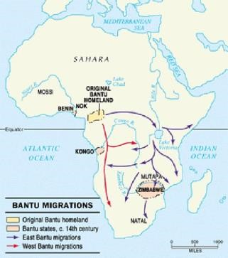
Theme 3: INTERACTION Between Humans and the ENVIRONMENT
– Geography (location, region, climate, natural barriers) – Demography and Disease – Migration – Patterns of Settlement – Technology impact –
- Environment shaped human societies, but, increasingly, human societies also affected the environment
- During prehistory, humans interacted with the environment as hunters, fishers, and foragers
- As the Neolithic revolution began, humans exploited their environments either as farmers of pastoralists
- Environmental factors such as rainfall patterns, climate and vegetation shaped the methods and exploitation used in different regions
- Exploitation of the environment intensified as populations grew
- As people flocked into cities or established trade networks, new diseases emerged and spread
- In recent centuries, human effects on the environment – and the ability to master and exploit it – increased with the development of more sophisticated technologies, the exploitation of new energy sources and a rapid increase in human population

 Interaction between Humans & the Environment
- In what geographic region is this located?
- What geographic landscape makes up the region?
- How are the people/events affected by the geography?
- How do the people interact with their environment?
- How does the environment define the culture/civilization?
- What are the patterns of settlement (urban/rural)?
- How do demography, movement and migration affect the spread of disease?

Theme 4: Development and Interaction
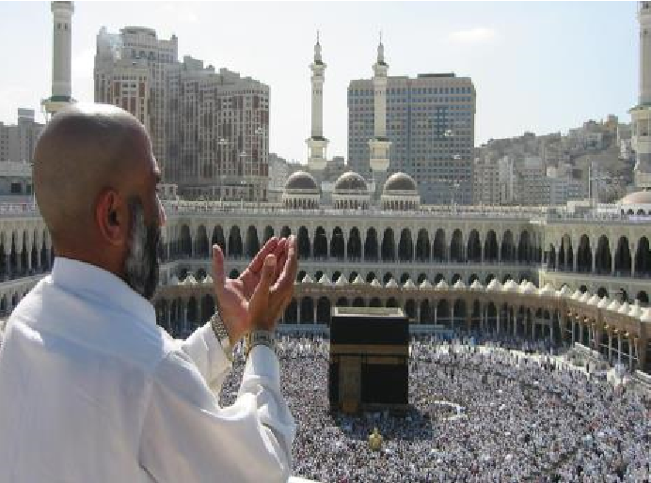
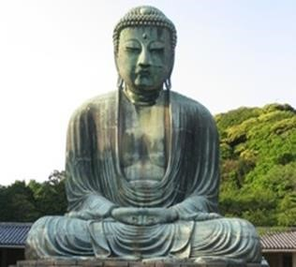
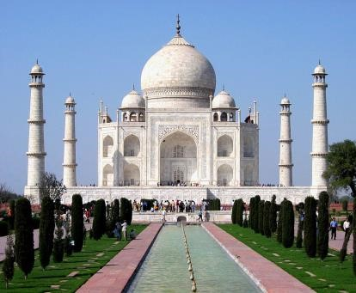
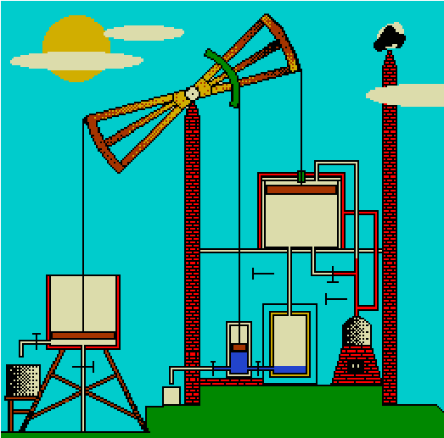
of CULTURES
- Religions – Belief Systems, Philosophies, and Ideologies – Science and Technology
- The Arts and Architecture –
- Cultural Development and interaction of cultures
- Explores the origins, uses, dissemination, and adaptation of ideas, beliefs, and knowledge within and between societies
- When people of different societies interact, the often share components of the cultures, deliberately or not. The process of adopting or adapting new belief and knowledge systems are complex and often lead to historically novel cultural blends (Syncretism).
- A society's culture may be investigated and compared with other societies' cultures as a way to reveal both what is unique to a culture and what is shares with other cultures.
- It is also possible to analyze and trace particular cultural trends or ideas across human societies

 Cultures
- What is the meaning of life?
- What is the religion (belief system) & what are the basic beliefs?
- Are there leaders or documents which define religion?
- What are the philosophies & ideologies?
- What groups are given the chance to learn?
- How do people learn & where does the knowledge come from?
- What are the developments in math & science?
- What innovations, technologies, & inventions develop?
- How do they express themselves through art, music, writing, literature?

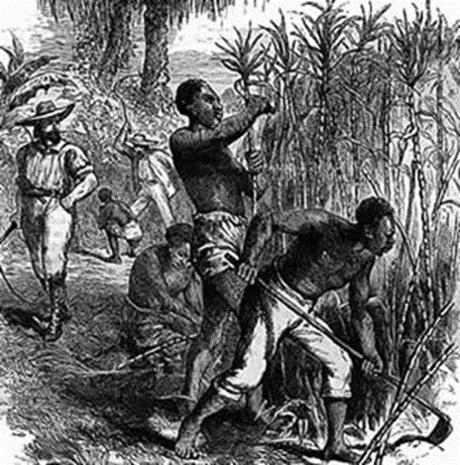
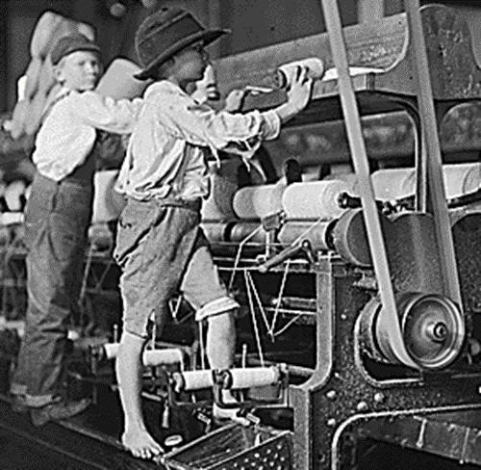
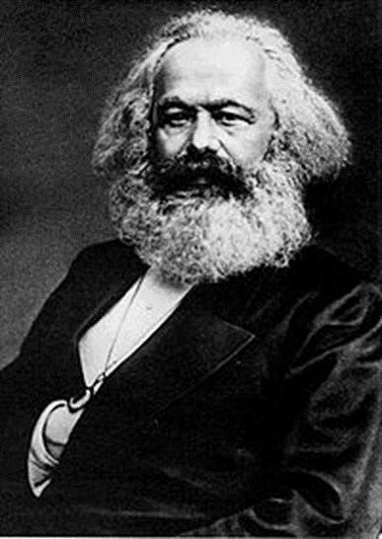
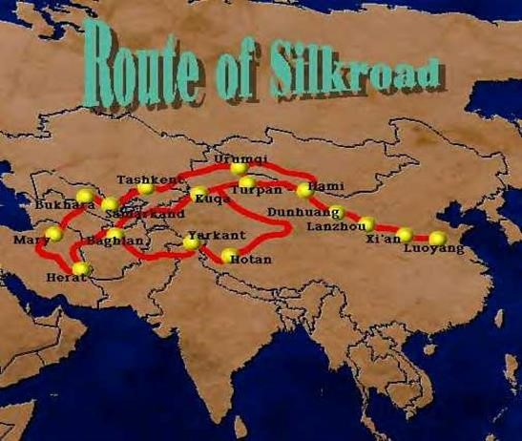
Theme 5: Creation, Expansion, and Interaction of ECONOMIC Systems
– Agricultural and Pastoral Production – Trade and Commerce – Labor Systems – Industrialization – Capitalism and Socialism –
- Creation, expansions and interactions of economic systems
- Surveys the diverse patterns and systems that human societies have developed as they exploit their environments to produce, distribute, and consume desired goods and services across time and space
- It stresses major transitions in human economic activity
- The development of various labor systems associated with these economic systems and the ideologies, values, and institutions (such as capitalism and socialism) that sustained them.
- Calls attention to patterns of trade and commerce between various societies, with particular attention to the relationship between regional and global networks of communication and exchange, and their effects on economic growth and decline

 Economic systems
- How do people earn their food?
- Is the economy based on agriculture, pastoralism, commerce, small trades or professions, or industry like manufacturing and technology?
- Where’s the money?
- What is the economic system (e.g. capitalism, socialism, communism)?
- What are the valued and traded commodities (e.g. silk, sugar, spices, cotton, consumer goods)?
- What are the patterns of trade and commerce between various societies (e.g. Silk Road, Trans-Saharan, Indian Ocean, Triangle Trade, NAFTA)?
- What is the labor system (e.g. slavery, coerced, semi-coerced, wage labor)?

